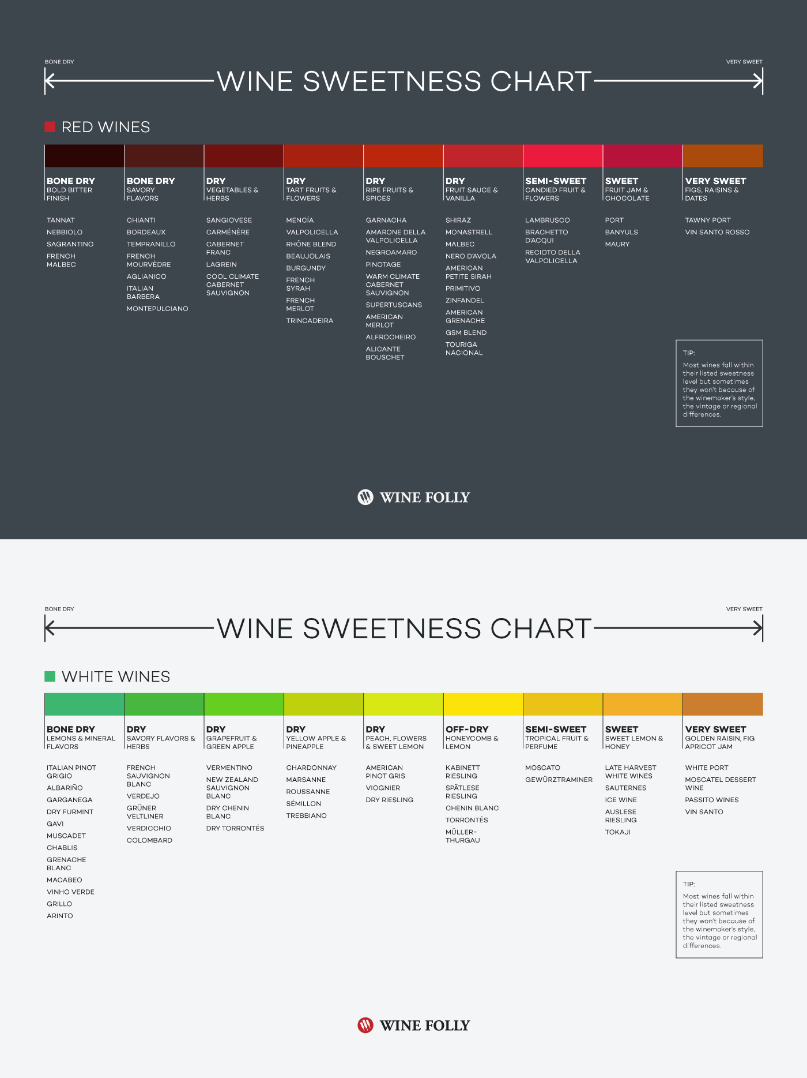

**Red Wines: Dryest to Sweetest - By the glass**

* Misconduct, The Big Take - Merlot 60%, Cabernet Franc 20%, Malbec 20%
* Bartier Bros, Syrah
* Crios, Malbec
* Quails Gate, Pinot Noir
* Whatchamacallit, Red Blend
* Rascal - Mon Ami, Red Blend

**Red Wines: Dryest to Sweetest - By the bottle**

* Black Hills, Syrah
* Tinhorn Creek, Cabernet Franc
* Black Hills, Note Bene (45% Cab Sauv, 40% merlot, 15% Cabernet Franc)
* Van Westen, Voluptuous (67% Merlot, 33% Cabernet Franc)
* Hester Creek, Cab Merlot
* Red Rooster, Merlot
* Cassini, Quattro (Merlot, Cabernet Sauvignon, Cabernet Franc, Petit Verdot)
* Laughing Stock, Portfolio

**White Wines: Dryest to Sweetest - By the Glass**

* Lagaria, Pinot Grigio
* Seven Terraces, Sauvignon Blanc
* Perrin La Vielle Ferme, Rose
* Rascal-Mon Ami, Blend
* Whatchamacallit, Chardonay
* Quail’s Gate, Guwurztraminer

**White Wines: Dryest to Sweetest - By the Bottle**

* Lake Breeze, Pinot Blanc
* Blue Mountain, Chardonnay
* Joie, Noble Blend
* La Fenz, Viognier
* Hillside, Muscat Ottonel
* Silk Scarf, Rose
* Deep roots, Parantage (80%Muscat, 15% Reisling, 5% Gurwurztraminer
* Origin, Gu (Guwurtzraminer)